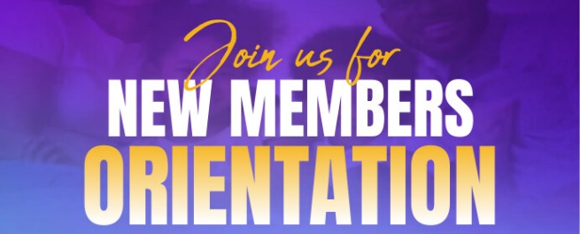


PLEASANT HILL CHURCH
NEW MEMBERS CONNECT MINISTRY
Return completed form as follows:
Hand deliver to PHC Usher
Email: newmembers@pleasanthillmbc.org
Fax: 770-302-9683

NEW MEMBERS’ ORIENTATION CLASS FACILITATORS: (Dr. Sabin P. Strickland, Senior Pastor)
Donna Johnson Martin – 404-246-1444
Minister Elington Bates Jae Bates
Gail Green Alford Thelma Gabb
Michelle Brown Carolyn Scott

Full name of NEW MEMBER: ________________________________________Date joined: _____________________
First Middle Last

Complete Address: _________________________________________________________________________________

Email Address: ____________________________________________________________________________________

Best Phone Contact Number: _________________________________________________________________________

Date of Birth: ____________________________

Additional NEW MEMBERS in household:

Full name of NEW MEMBER: ________________________________________Date of Birth _____________________
First Middle Last

Full name of NEW MEMBER: ________________________________________Date of Birth _____________________
First Middle Last

Full name of NEW MEMBER: ________________________________________Date of Birth _____________________
First Middle Last

Full name of NEW MEMBER: ________________________________________Date of Birth _____________________
First Middle Last

FEEDBACK SECTION: ___________________________________________________________________
_________________________________________________________________________________________
_________________________________________________________________________________________
_________________________________________________________________________________________
Please stay tuned for information regarding scheduled classes

